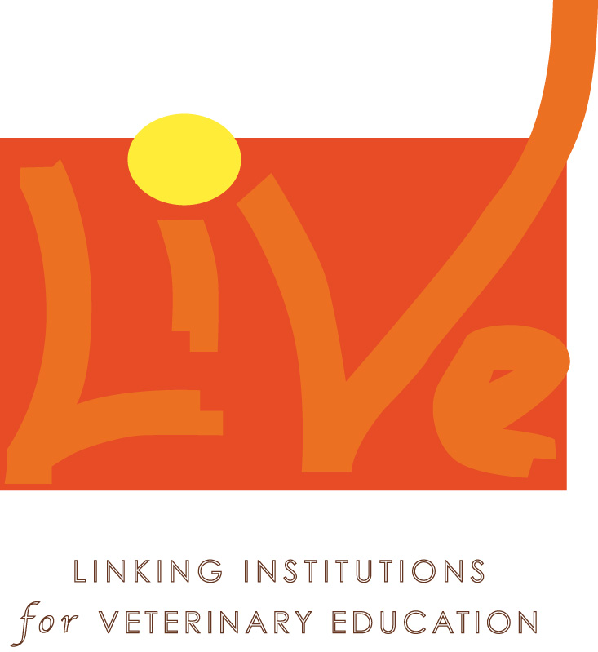



Direttore: Prof. Edi Piasentier

UNIVERSITA' DEGLI STUDI DI UDINE
DIPARTIMENTO DI SCIENZE ANIMALI

Mr./Mrs.
Date of birth place of birth
Full address

National insurance number

STATEMENT OF EXPENSES FOR MISSION/MEETING CONCERNING LIVE PROJECT Contract No. 9-ACP-RPR-118#6

(Name/Surname) declare under my own and sole responsibility to have accomplished the following mission for (specify the reason of the mission)

DEPARTURE
From State
Date Time

DESTINATION
State

END OF THE MISSION
Date Time

TRAVEL EXPENSES (to be fully documented with invoices, tickets etc)

Means of Transport  (Train, ship, plane, bus; Taxi if justified) | From | To | Currency | €

Own car/vehicle | From | To | Total Km | €/Km
Own car/vehicle |  |  |  | 0,206583

I declare under my own and sole responsibility that the mission/participation of meeting has been accomplished in order to implement L.I.V.E Project, I commit to full fill all the obligations according to this mission/participation to meeting.
I commit to refund to Università degli Studi di Udine-Dipartimento di Scienze Animali any sum of money I have paid out for activities not strictly connected to the L.I.V.E. Project.

Further notices

date, place Signature
for Perdiem rembursement enclose :hotel bill or boarding passes+timesheet+ visit report
Do not write underneath this line
TO BE FILLED IN BY THE ACCOUNTING OFFICER

PERDIEM CURRENCY EXCHANGE _______________
DAYS/HOURS | PER DIEM | TOTAL AMOUNT PER DIEM |  | DATE | €
 | TOTAL*

*Importo non assoggettato a IRPEF per mancanza dei presupposti di imponibilità previsti dall’art. 3 e dall’art. 23 c. 1 e c. 2 del DPR 917/86 TUIR

LIQUIDAZIONE TOTALE/TOTAL AMOUNT OF THE MISSION/MEETING
SPESE DI VIAGGIO/TRAVEL COSTS €
MEZZO PROPRIO/OWN CAR/VEHICLE €
PERDIEM €.

TOTAL AMOUNT DUE €.
Udine,

The Director and Project Vice- Coordinator
_________________________________

Anno | Cat. | Cap. | Art. | Fondo | Obbl. | Pag.

_______________________________________________________________________________________________
Via San Mauro, 2 - 33010 PAGNACCO (UD) ITALIA - Tel +39 0432/650110 - Fax +39 0432/660614

NOTA BENE:The State/nation of departure and of arrival has to be ALWAYS indicated in order to properly calculate the per diem reimbursement amount, if no indication is given “per diem rate”shall not be refund

